#### **1. What is the result of the code, and why?**

>>> def func(a, b=6, c=8):

print(a, b, c)

>>> func(1, 2)

**Ans:** The result of the above code is 1 2 8. its because the function uses the default value of c ie 8 which is provided at the time of declaration

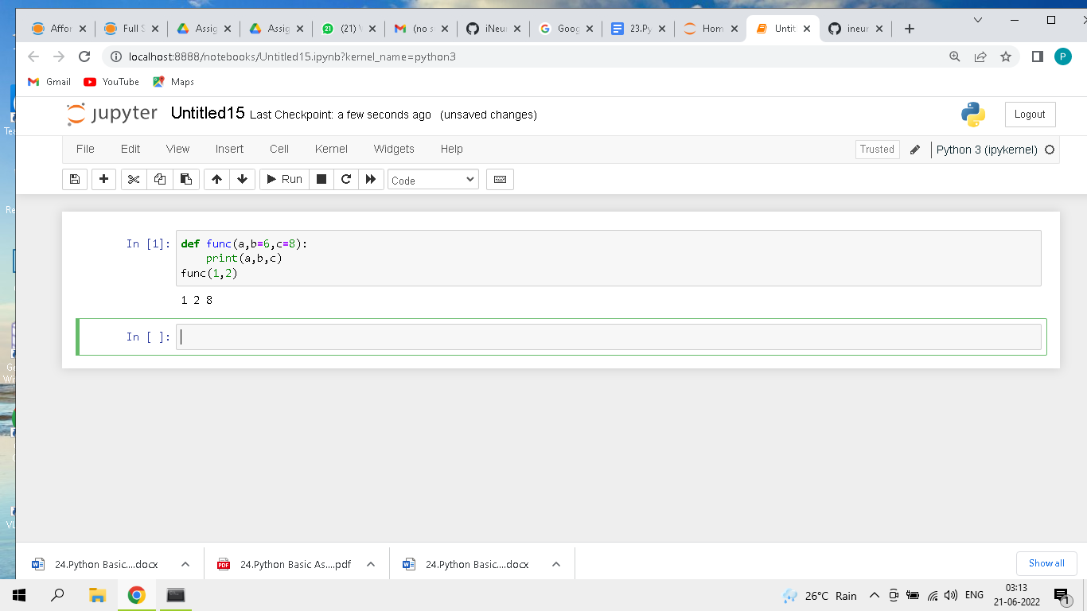

#### **2. What is the result of this code, and why?**

>>> def func(a, b, c=5):

print(a, b, c)

>>> func(1, c=3, b=2)

**Ans:** The result of the above code is 1 2 3. it is because the function will use default values only when a value for a argument is not provided and if argument name is mentioned while doing a function call, the order of arguments is also ignored by the python interpreter

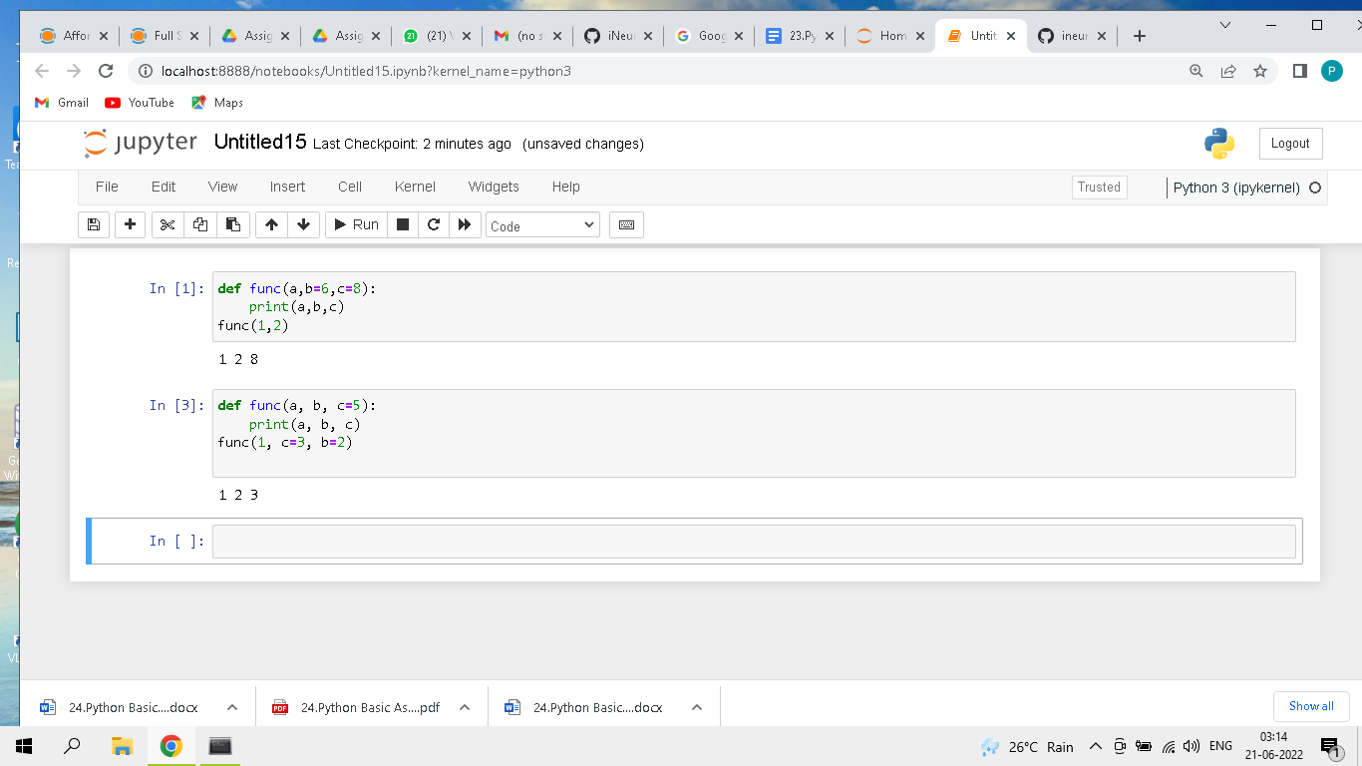

#### **3. How about this code: what is its result, and why?**

>>> def func(a, *pargs):

print(a, pargs)

>>> func(1, 2, 3)

**Ans:** The result of the code is 1 (2,3). *pargs stands for variable length arguments. this format is used when we are not sure about the no of arguments to be passed to a function. all the values under this argument will be stored in a tuple.

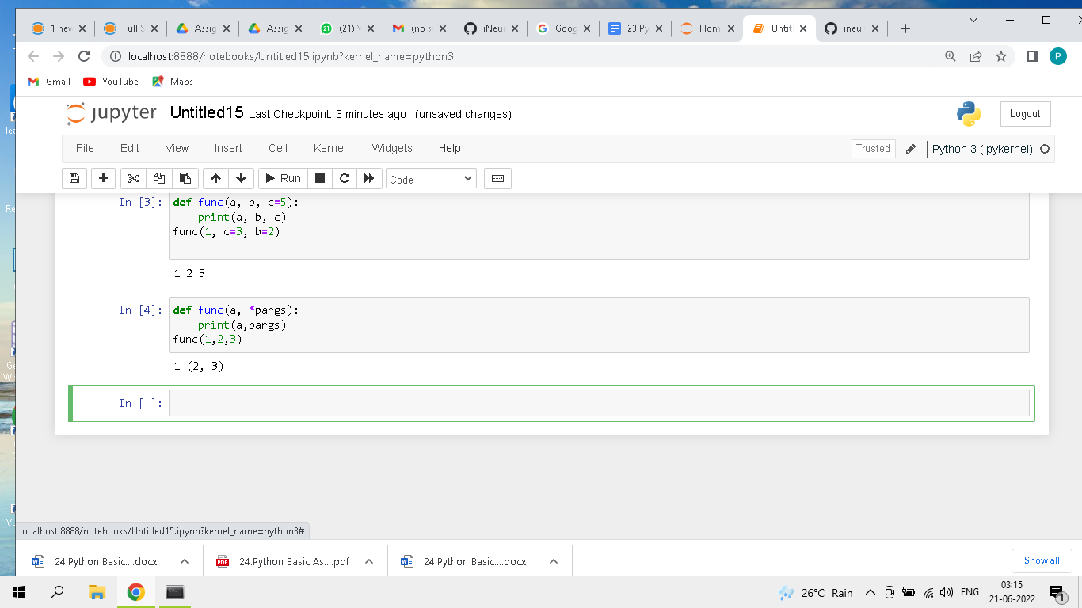

#### **4. What does this code print, and why?**

>>> def func(a, **kargs):

print(a, kargs)

>>> func(a=1, c=3, b=2)

**Ans:** The result of the above code is 1 {'c': 3, 'b': 2}. **args stands for variable length keyword arguments. this format is used when we want pass key value pairs as input to a function. All these key value pairs will be stored in a dictionary

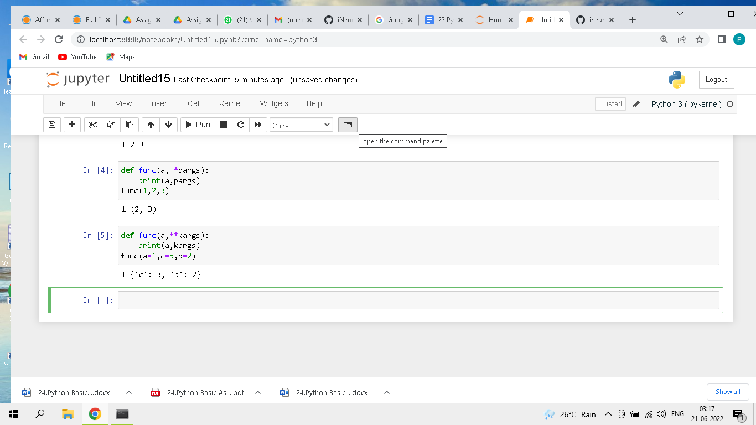

#### **5. What gets printed by this, and explain?**

>>> def func(a, b, c=8, d=5): print(a, b, c, d)

>>> func(1, *(5, 6))

**Ans:** The output of the above is 1 5 6 5. The reason for this function not throwing an error is because this function expects 4 arguments. the value for a is provided explicitly whereas for arguments b and c, the function will expand the *(5,6) and consider the value of b as 5 and value of c as 6. since the default value of d is provided in function declaration d value will be 5. However it is recommended to use the feature of positional arguments at the end.

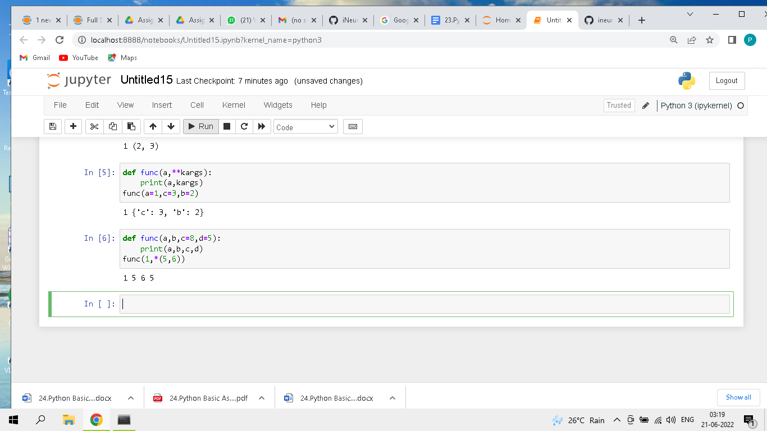

#### **6. what is the result of this, and explain?**

>>> def func(a, b, c): a = 2; b[0] = 'x'; c['a'] = 'y'

>>> l=1; m=[1]; n={'a':0}

>>> func(l, m, n)

>>> l, m, n

**Ans:** The output of above code is 1, ['x'], {'a': 'y'}.

1. Even Though Python gives importance to indentation. its provides a facility to declare an entire function in one single line. where statements in a function body are separated by ;
2. When l,m,n are provided as inputs to the function. its modifies the values of l,m,n and sets the value of l=2 ,m=['x'] and n={'a':'y'}

